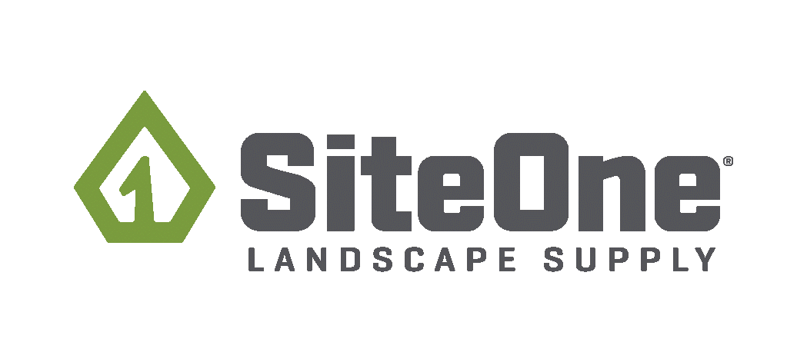
Customer Sales & Service Rep
Harrisburg, South Dakota: 27278 Kenworth Pl Ste 4 Harrisburg, South Dakota 57032
Please email resume to klowery@siteone.com to apply!

Job Description
Company Overview
Whether you are experienced in the green industry, a professional looking for a career change, or a new graduate or veteran transitioning into the workforce, we are confident you will find opportunity and reward with SiteOne.

SiteOne Landscape Supply is the largest and only national wholesale distributor of landscaping products in the United States and Canada. With over 500 branches across the U.S. and Canada, we offer a comprehensive selection of products including: irrigation supplies, fertilizer and control products, nursery goods, hardscapes, landscape lighting, drainage and erosion control products, tools, and other landscaping accessories and supplies.

Come grow with our associates who are customer obsessed, always safe, continuously improving, and having fun!
Position Overview
Our Counter Sales associates are knowledgeable, energetic and consistently deliver the best overall customer experience. To succeed in this role, you need to be passionate and customer obsessed while serving commercial and residential consumers in the green industry.

What you’ll do:
- Demonstrate exceptional customer service to all SiteOne customers
- Cultivate and manage strong relationships with customers
- Assist customers with their questions and needs, either in person, via the phone or through online ordering
- Pull and prepare inventory orders for customer pick up or delivery
- Proactively identify and capitalize on opportunities to grow sales with current and potential customers
- Assist with merchandising product and managing inventory. Store tasks include cycle counts, inventory, spot counts and end of the day process
- Maintains a safe working environment
Skills We Are Seeking
- Excellent customer service skills
- Ability to think quickly and make decisions
- Inventory management experience helpful
- Understand of inventory management
- Must be able to lift a minimum of 50 pounds
- High school or secondary diploma or equivalent preferred
- Nursery, Irrigation, or Landscape experience is a plus
Perks:
- Medical, Dental and Vision plans
- Paid Time Off, Paid Holidays
- Competitive Compensation
- 401k with company match
- Company paid life insurance, Short Term Disability and Long-Term Disability Insurance
- Product Discounts
- Tuition Reimbursement
- Opportunity for Advancement
THE INFORMATION CONTAINED HEREIN IS NOT INTENDED TO BE AN EXHAUSTIVE LIST OF ALL RESPONSIBILITIES, DUTIES AND QUALIFICATIONS REQUIRED OF INDIVIDUALS PERFORMING THE JOB. THE QUALIFICATIONS DETAILED IN THIS JOB DESCRIPTION ARE NOT CONSIDERED THE MINIMUM REQUIREMENTS NECESSARY TO PERFORM THE JOB, BUT RATHER AS GUIDELINES. THEY MAY VARY FROM POSITION TO POSITION.

