Happy Hollow Club
Omaha, Nebraska
Posting for Director of Grounds / Golf Course Superintendent
Post as of 9.28.21

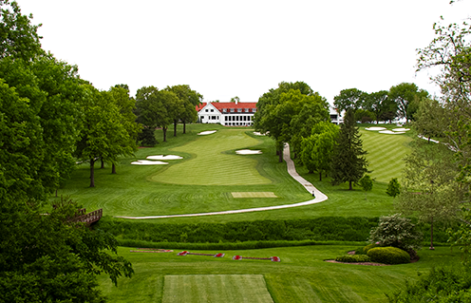
GENERAL CLUB INFORMATION
Happy Hollow Club was first established in 1907 and originally located in downtown Omaha. The club moved to its current 175-acre location in 1924 and has maintained its prestigious reputation as the club of choice ever since. Happy Hollow is as genuine and gracious by nature, as it is distinctive in quality and service. We are one of Omaha's top premier private country clubs, celebrating friends and families coming together to enjoy the best of times in a truly distinctive setting. Centrally located, the club is minutes away from downtown Omaha, high-end shopping, world-class entertainment, and luxury real estate.

FACILITY INFORMATION
The Club boasts a broad array of activities and sporting opportunities for couples, families, and professionals including golf, tennis, fitness, swimming, and exquisite dining venues. This exceptionally rich year-round calendar of events and activities offers abundant time to visit with loved ones and nurture new friendships in this exclusive yet inviting home away from home.
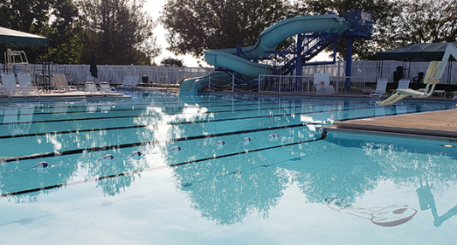
The wide range of athletic activities which includes world class teaching programs for personal and junior instruction. The PGA golf professionals and USPTA tennis professionals on staff lead an exceptional family friendly program. Full club privileges include a fitness center, a large recreational/lap swimming pool, 5.5 tennis courts with the ONLY year-round, private domed, tennis facility in the Omaha area, and an immaculate 18-hole championship golf course with three practice holes, two driving ranges, and one of country’s finest retail pro shops, named The Den. Happy Hollow provides a complete experience to anyone who enjoys golf, tennis, swimming, or social activities in a superlative setting.
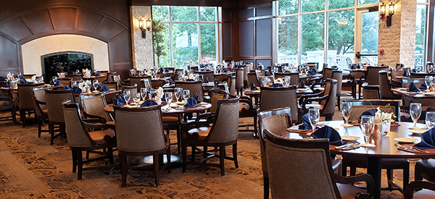
The Clubhouse is expansive with 77,000 square feet and is the heart of the social experience at Happy Hollow. Elegant and traditional in design, it serves as a gathering place for our Members and their guests. With a variety of dining options for its Members, both casual and formal, as well as rooms for professional use, Happy Hollow Club is the natural choice for Members’ to host their events.
In the Fall of 2020, Happy Hollow opened an amazing new complex called the Activity Center. The Activity Center boasts a one-stop-shop for all our activities at the club including a five and half court tennis and pickleball dome, basketball court and kids play area, a deluxe fitness and cardio space, full-service tennis pro shop, golf training and simulators, and family-friendly casual dining with indoor and outdoor spaces called 1907 Langfords. This new Activity Center is located to the north of our already existing “resort style” swimming complex.
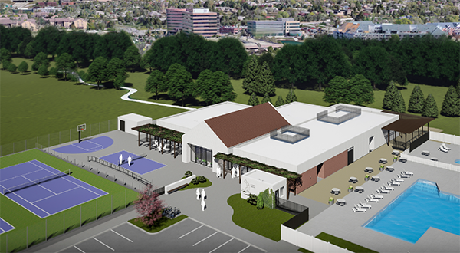
CLUB / STAFF CULTURE
In season, the team welcomes an average of 260 employees providing a superlative mission and vision to the Happy Hollow Club members and guests. Taking care of and supporting each other is as important as taking care of the membership. We have a mindset of “work hard – play harder”. When you are on property you have a fantastic attitude of “We are going to have a great day taking care of each other and the members!” The club has an extremely strong tradition of having employees spend the better half of their lives working at HHC. Over the past decade, we have had over a dozen employees in all departments that have a tenure that exceeds 25 years with the longest still on staff at 47 years of continual employment.
MEMBERSHIP INFORMATION
Happy Hollow has 1,080 families that are divided between Full (Golf), Social, and Clubhouse memberships. Currently, the club has 415 golf members with an active golf season from April to November, averaging 18,000 rounds annually. Currently, the club has substantial waitlists for our Full Golf and Social membership categories.

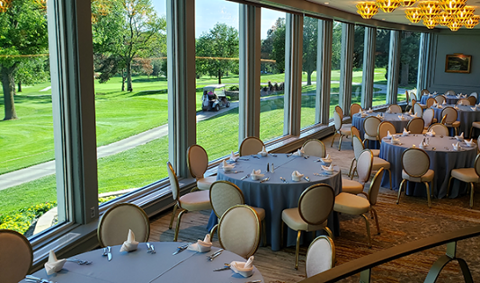
HAPPY HOLLOW FINANCIAL BACKGROUND
- Overall revenues at the club include initiation fees, dues, food and beverage, and other sales totaling about $13,500,000 annually. The club enjoys an exceptionally busy and well-regarded banquet and event business which is an important part of the overall business plan.
- Average Food and beverage sales average $4,000,000 with 45% of that being in banquets and events.
- The club is organized as a 501©7, tax exempt, not for profit entity.

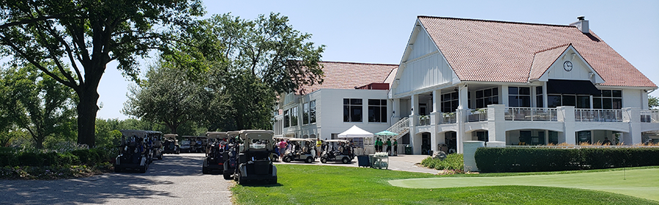
OVERVIEW OF THE AGRONOMIC DEPARTMENT AND SPECIFICS RELATED TO THE OPEN POSITION OF DIRECTOR OF GROUNDS / GOLF COURSE SUPERINTENDENT

Beloved Superintendent Retiring
At the end of the 2021 season, Scott Axon, the club’s 29-year veteran superintendent, is retiring. Scott is departing on fantastic terms and is leaving the 177 acres in tremendous shape. His efforts and that of his long tenured team have the property in ideal shape for this transition. We are forever grateful for Scott’s dedication and passion for creating an incredible experience for the members and guests for almost three decades.

Happy Hollow Agronomic Mission Statement and Objectives

To prepare, preserve, and maintain the golf course as the major club asset, and to afford the opportunity to provide beauty and enjoyment to the club's members and guests.
To protect and fulfill the golf course architect’s and membership's vision and goals for a fair golf challenge for all levels of player abilities.

To plan and execute programs and procedures that results in the golf course at Happy Hollow Club that is the best maintained golf course in Omaha and ranks in the top quartile when compared to the golf courses at the clubs in our Midwestern peer group.

To provide a golf course to the members of HHC that is aesthetically pleasing and with a "fit and finish" that is commensurate with high end country club courses in this region.

Objectives

The course will be maintained such that excellent playing conditions exist for both high and low handicap golfers. The course should play and be prepared daily in adherence to these standards, realizing that weather can provide limitations. The goal is to minimize player interference and golf course inconsistencies while at the same time maintaining the course at a high standard while considering environmental stewardship and proper resource allocation.

These objectives will be met within an overall annual capital and maintenance budget prepared by the General Manager and Course Superintendent and approved by the Board of Directors. Any significant variance to the annual maintenance budget will be subject to the same approvals. This template is the board’s and General Manager’s basis for evaluating the performance of the Course Superintendent and staff.
Ideal Candidate for the position
It is a given that this person would be a trained, proven, educated, capable, experienced, and knowledgeable expert in the field of golf course maintenance and care. This person always possesses a team attitude and cares deeply about his or her agronomic personnel and spends the majority of his or her time, teaching and educating, mentoring, motivating, and inspiring them. They understand that although they are the experts in their field and will not be micromanaged, that we work for the membership of HHC and will be open to suggestions and constructive feedback whether that be by the Board of Directors, Green Committee, or General Manager. They are excited to come to work each day to serve the team and the membership to the best of their ability. They have extensive work experience and knowledge in this field within 300 miles of Omaha understanding the ever-changing weather conditions we experience every year.

Essential Job Duties and Responsibilities

- Maintains all grounds according to the “HHC Course Maintenance Standards” (last reviewed and adopted in 2019).
- Responsible for the maintenance, repair, and replacement of all golf course and grounds equipment.
- Expected to foster a culture of teamwork and mentorship which is essential for success at HHC in all departments. The superintendent will schedule, train, motivate, and inspire all personnel in the department.
- Perform annual performance reviews for all personnel under their care and submit to the Business Office for each employee’s file.
- Must maintain accurate employment records for all personnel in the department. (I.E. New hire paperwork, counseling sessions, approved raises, bi-weekly timecards, etc.)
- Supervises all planting, fertilizing, and care of plants, flowers, shrubs, trees, and other facilities on the golf course.
- Leads, presides, and schedules the “HHC Greens Committee”.
- Leads, presides, and schedules the “Tree Planting, Removal, and Maintenance Committee”.
- Inspects course regularly and alerts General Manager and / or appropriate department heads of all items where a member or guest might inquire. We are all a team and sharing information aides everyone.
- Welcomely performs periodic golf course tours with the General Manager with the intent of educating them on projects, challenges, and initiatives.
- Oversees all construction, maintenance, and renovations on the golf course.
- Oversees repairs of broken water lines or valves and may perform necessary repairs in an emergency.
- Prepares annual operations budget for department. This includes yearly recommendations for equipment and other capital improvements and purchases.
- Provides monthly proactive updates to GM and Controller on status related to monthly budget.
- Establishes short- and long-range plans for the golf course and equipment.
- Selects and prepares proper fertilizers and nutrients for all flora and fauna.
- Develops and maintains drainage, irrigation, and watering systems.
- Implements and enforces comprehensive safety program for employees, members, and guests on course in compliance with local, state, and federal laws; implements and manages the club’s hazard communication (HAZCOM) program.
- Ensures that chemicals, petroleum, and other controlled products are used, stored, and disposed of in accordance with local, state, and federal regulations; maintains required records and strives to minimize the use of chemicals and petroleum products.
- Communicates with the Director of Golf and General Manager to discuss conditions of facilities, maintenance plans, scheduled events, and the number of rounds played.
- Is willing and able to aide General Manager in communications with the Board of Directors as needed. (I.E. Attend some board meetings, etc)
- Attends weekly team leadership meetings led by the General Manager.
- Writes a monthly agronomic newsletter to the membership.
- In conjunction with the Director of Golf, keeps members informed about current and future maintenance activities.
- Conducts daily facility security checks ensuring accurate inventory of equipment and keys.
- Assists the non-agronomic team with seasonal projects such as the install and removal of tennis dome, 3rd of July celebration, etc.
- Plans professional development and training activities for themselves and for their golf course maintenance team including safety training for equipment use and proper handling of fertilizers, herbicides, and all other chemicals used on course; assures that MSDSs are available in a convenient location.
- Annually plan for staff safety protocol training including CPR/AED/O2 and emergency response operations.
- Maintains an “event log” to record and document any injury or emergency incidents within their department and reports any occurrences directly to the GM/COO and other appropriate parties.
- Supervises road and roadside maintenance within the Club’s grounds.
- Ensures proper landscaping for property outside of the golf course blueprint including the clubhouse, parking lot, area outside of the West fences along 105th street, and other surrounding areas.
- Performs snow removal and de-icing of the parking lot and all non-golf course concrete paths and sport court.
- Coordinates applicable work with outside contractors and venders.
- Determines when course should be closed due to weather conditions that may damage the course if play continues.
- Conducts other appropriate tasks assigned by the General Manager.

Desired Qualifications, Certifications, and Education
- Bachelor’s degree in Agronomy, Horticulture, Plant Science or an Associate’s degree from an intensive two-year turf grass management program.
- Additional training in mechanics, design, surveying, and ecology a plus.
- Previous experience as a Golf Course Superintendent or as an Assistant to an experienced Golf Course Superintendent required.
- Possess a basic understand the rules of golf.
- Be up to date on federal, state, and local laws on golf course operations, including but not limited to chemical and fertilizer applications.
- Must possess administrative and executive ability which is especially critical in problem solving and decision making.
- Certified Golf Course Superintendent (CGCS) a plus.
- Pesticide Application certification required.
- Valid driver’s license.
- Bilingual in Spanish is preferred.
- Having extensive work experience in Nebraska or within close proximity is a strong plus.
- Having strong family and or social ties close to Omaha is a strong plus.

Work Conditions and Physical Requirements
- Frequently exposed to moving mechanical parts and outside weather conditions.
- Frequently exposed to fumes or airborne particles and toxic or caustic chemicals.
- Occasionally exposed to wet and/or humid conditions; high, precarious places; extreme cold; extreme heat; risk of electrical shock; and vibration. The noise level in the work environment is usually moderate to loud.
- Frequent lifting, bending, climbing, stooping, and pulling.

ORGANIZATIONAL STRUCTURE
In the Happy Hollow Club organization, the Director of Agronomy reports directly to the General Manager/COO. The General Manager reports directly to the Happy Hollow Board of Directors.
Happy Hollow Club Greens Committee – Ingrained in our Mission, Vision, and employment culture, is the premise that we are employed to serve the members of the club. There are numerous Member committees that meet with various departments heads periodically to exchange information back and forth between the staff. These are recommending bodies to the Board of Directors. There is a Greens Committee at HHC that the Director of Agronomy and the General Manager meets with several times of year.

SALARY & BENEFITS
Salary is open and commensurate with qualifications and experience.
The club offers an excellent benefit package. Additional income is derived from a year-end performance/holiday bonus approved by the General Manager and Happy Hollow Club Board of Directors.
Benefits include: Health, Dental, and Vision Insurance (Club and employee share premium costs), Health Reimbursement Account (HRA), Life and Disability Insurance Offered, 401K, GCSAA or other related association Dues Paid, Paid Vacation, Education Allowance, Meals, Cell Phone Reimbursement, Work Vehicle, Industry Conference Allowance, and Clothing Allowance.

Qualified applicants may submit resumes only to the following email address: HR@happyhollowclub.com
Cover letter and resume deadline submission is Sunday, October 24th, at 5:00 pm. However, interested individuals should not delay in submitting information.
GM/COO OF HAPPY HOLLOW CLUB
David Schneider, PGA, CCM has been the General Manager/COO of Happy Hollow Club since January of 2018. He has been a PGA member since 1996 and has served as the General Manager, Director of Golf, Facility Manager or Director of Operations at facilities in Arizona, Hawaii, Iowa, and Nebraska since 1997. He has worked in one of those capacities at Troon North Golf Club and Legend Trail Golf Club in Scottsdale, Waikoloa Beach Resort in Waikoloa, HI, Ventana Golf and Racquet Club in Tucson, Arizona, and Wakonda Club in Des Moines, Iowa. He is very active in the PGA, where he just concluded a four-year term serving on the National Board of Directors representing the states of Nebraska, Iowa, Minnesota, and the Dakota’s.

